Table of Contents

Abstract 2

Introduction 3

Short linear motifs 3

Protein interactions modules 3

Short linear motifs and molecular recognition features 3

Classes of Short Linear Motifs 4

Representing motifs computationally 6

Changing function by interaction network rewiring via protein expression, evolution and splicing 8

Linear motif vs domain evolution 9

Challenges in discovering linear motifs and how to address them 11

Abundant but hard to discover 11

Experimental strategies 11

Computational methods are necessary 11

Viral proteins rely extensively on the molecular mimicry of cellular linear motifs 12

De-novo discovery of human linear motifs convergently evolved in viral proteins 13

Results & Discussion 14

Degree distribution in human and human-viral protein interaction network 14

Viral-human network is asymmetric: viral proteins interact with more human proteins than human proteins interact with viral proteins 14

Viruses target human proteins that appear as hubs only in the data biased for more well-studied proteins 15

Dataset for benchmarking 18

Domains likely to mediate interaction are enriched in SLIM-binding domains 19

De-novo discovery of Short Linear Motifs 20

Filtering by domain improves accuracy of motif prediction 21

De-novo discovered motifs are similar to known motifs 22

Examples of recovered and candidate motifs 24

Several classes of candidate motifs recovered and predicted alongside and their likely recognition domains 24

Successfully recovered 2 known PDZ-domain binding motifs 25

PDZ-domain binding candidate motifs 25

SH3-domain binding candidate motifs 25

WD40-domain binding candidate motifs 25

Double-stranded RNA-binding domain and EF hand domain - candidate motifs 26

BAG-domain binding candidate motif 27

Future directions 28

Motif-domain molecular docking 28

Integrating multiple predictors: domain, motif, molecular docking 28

Experimental validation 28

Conclusions 29

Methods 30

Protein interaction data 30

Degree distribution analysis 30

Protein sequences and domain prediction 30

Estimating which domains are likely to mediate interaction 30

Motif Search tools and setup 30

Benchmarking instances of motif 30

Dataset 30

Motif pattern similarity 30

Data analysis in R 30

Supplementary materials 31

Supplementary figure 1 31

Supplementary figure 2 32

Supplementary figure 3 33

Supplementary figure 4 34

Supplementary figure 5 35

Supplementary figure 7 37

Supplementary figure 8 38

Abstract

Viral proteins rely extensively on the molecular mimicry of cellular linear motifs for modifying cell signalling and other processes in ways that favour viral infection. This study aims to de-novo discover human linear motifs convergently evolved in disordered regions of viral proteins. We systematically apply computational motif prediction tools to the human-viral and human-human protein interaction network. By limiting the search space to the sequences of viral proteins (by searching only for motifs also present in viral proteins we limit the search space and) we can increase the sensitivity of motif prediction. We can recover known linear motif occurrences in viral proteins. By estimating recognition domain identities and utilising alternative human-human interaction datasets we further improve our ability to recover these motifs. We experimentally validate X novel human recognition domain - viral motif pairs using peptide arrays. This work contributes to our understanding of the domain-linear motif code and how viruses exploit this mechanism.

#We demonstrate that using the sequences of viral proteins that have convergently evolved #linear motifs increases the sensitivity of computational linear motif prediction.

#This work may aid the discovery of novel functional linear motifs and instances, thus #contributing to our understanding of the domain-linear motif code and how viruses exploit this #mechanism.

#I have devised each step of the analysis (retrieve/process experimental interaction data, #identify domains, motif search on sequences of interacting partners of viral-interacting human #proteins, scoring domain-motif pairs) and implemented them in R #(https:/github.com/vitkl/MItools), using command-line tools and LSF computing cluster.

Introduction

Short linear motifs

Protein interactions modules

   The structure and the function of the cell arise from interactions between molecules inside and outside it [@Hein:2015aa]. Though proteins, nucleic acids, lipids and small molecules can all form important interactions, studies and literature focus mainly on interactions between proteins and other macromolecules. These interactions govern cellular processes and organismal phenotypes from cell death to muscle contraction. Disrupting or introducing new a protein contact often constitutes a molecular basis of disease or an evolutionary adaptation. To produce these phenotypes proteins interact under specific conditions in defined cell types and subcellular locations. This way interactions organise biochemical and enable structural functions of the protein. All aspects of protein function are conducted by modules embedded in its sequence. These modules can be folded in a stable 3D structure under native conditions (globular domains) or lack a stable 3D structure (disordered regions). Globular domains reserve a variety of functions requiring a precise spatial position of amino acid residues and a rigid structure: enzymatic, ligand-binding (DNA, lipids, peptides) or structural functions. Globular domains constitute a majority of known protein interaction interfaces, however, most of these interactions are very stable and lack dynamical properties necessary for inducible and transient interactions. The functionality of globular domain-mediated interactions is complemented by short linear motifs (SLIMs or linear motifs) located in flexible disordered regions.

Short linear motifs and molecular recognition features

Short Linear Motifs (SLIMs) are sequence motifs of 3-15 amino acid residues that mediate physical and selective interactions between proteins. The linear sequence of the motif not it’s three-dimensional structure is considered to be important for binding. Short Linear Motifs are usually located in the disordered part of a protein. This can be a long disordered region or a short loop on the surface of a globular domain. The flexibility of this region allows globular domains of the interacting partner to recognise the sequence of a Short Linear Motifs. Only 1-5 amino acid residues may be strictly required for recognition while certain amino acids (such as proline) may abolish binding. The shape of the binding pocket determines the sequence specificity of recognition domain.

Domain family (such as SH2, SH3, PDZ domain) has a broad specificity for a class of motifs (phosphotyrosine motifs, proline-rich motif or C-terminal motifs). In contrast, a specific instance of a domain in a protein can recognise a more specific motif sequence in a limited set of proteins. For example, the SH2 domain of GRB2 binds phosphorylated pYENV motif of receptor tyrosine kinases leading to inducible recruitment, while the SH2 domain of Src recognises pYEEI motif in the sequence of Src itself causing the autoinhibition of the kinase (PMID: 11719057). The sequence context around phosphorylated tyrosine determines which SH2 domain-containing proteins will be recruited and which signalling pathways activated. Other docking motifs and their recognition domains complement the low specificity of protein-serine/threonine kinase domains (such as those of MAP kinases) towards their targets (PMID:11371562). As illustrated in these examples, Short Linear Motifs mediated interactions can be inducible, transient and serve regulatory functions.

Both domains and motifs can have a different degree of binding specificity towards their partners. Multiple domains can recognise the same promiscuous motifs or the same promiscuous domain can recognise multiple motifs.

    Motif-mediated interactions are the weakest of 3 main types: domain-domain interaction, domain-motif interactions and domain-MORF interactions. These types of interactions differ by the area of interaction interface that, in turn, determines affinity. Domain-domain interactions are the strongest (picomolar affinity) and are usually involved in stable protein complex formation. In domain-MORF interactions a disordered region of one protein undergoes disorder-to-order transition gaining a stable 3-dimensional structure in a complex. These interactions have the intermediate strength (nanomolar affinity). The low affinity of motif-mediated interactions (low micromolar affinity) affects the dynamics of interactions enabling fast switching or requiring the presence of multiple motifs for high-avidity biologically relevant binding. This along with other properties of SLIMs makes the ideal for connecting protein complexes (@Hein:2015aa, PMC4191887), targeting proteins to a specific organelle or assembling functionally different complexes around the invariant core (proteasome, transcription initiation machinery). This way, SLIM-mediated interactions constitute the molecular basis for almost all cellular processes.

Classes of Short Linear Motifs

As more instance of Short Linear Motifs were discovered the research community has agreed to define 6 classes of motifs: ligand-binding, targeting, docking, degradation, post-translational modification and cleavage sites.

Motifs can be classified into 2 general groups: motifs that mediate binding or motifs that are a target for post-translational modification. Each of these groups can be further subdivided.

Ligand-binding motifs

Classic ligand-binding motifs (called LIG in ELM database) mediate a protein complex assembly - including functionally distinct complexes around the same invariant core or the scaffolding of proteins forming the same pathway. For example, nuclear receptors recruit transcriptional repressors or activators via CoRNR motif or NR box motif respectively depending on their binding of steroid hormone - their ligand (15276186). Scaffold proteins can regulate cell signalling in multiple ways: from specifying linear pathways by arranging kinases the right order (such as KSR that organises MAP kinase cascade) to inhibition via scaffold titration or allosteric regulation (21551057).

Other ligand-binding motifs have a regulatory effect. Targeting motifs (TRG in ELM database) drive the correct localisation of proteins by directing translocation of proteins between subcellular compartments via specific transport pathways (trafficking motifs, e.g. nuclear localisation signal, nuclear export signal) - or by retaining a protein in the correct location via anchoring this protein to a compartment-specific complex (SxIP-motif recognised by EBH domain of microtubule end-binding proteins [22885064]).

Docking motifs (DOC in ELM database) serve to recruit modifying enzymes and are used extensively to increase the substrate specificity of enzymes. Docking motifs often guide enzymes to modify a different site in the substrate. Docking motifs can drive substrate recognition via 3 main modes. Motifs can be recognised by a site in a catalytic domain distinct from the catalytic site. For example, a docking groove of MAP kinase catalytic domain recognises motif in MEF2A, MAP2K1 or MKP1. Alternatively, a separate interaction module located in the same protein recognises. Previously mentioned SH2-domains often serve this function. Not only the SH2 domain of Src kinase is involved in autoinhibition but also in substrate recruitment such as recruiting FAK1 kinase by recognising pYAEI motif. Finally, recognition domain that binds a substrate can be located in a different protein (not the enzyme itself) that forms a complex with the enzyme. This complex has to be assembled first and may rely on either linear-motif or domain-domain -mediated interactions. One example is CDK (cyclin-dependent kinases) that rely on a recognition domain in a cyclin protein to recognise their targets [16707497].

A special subset of docking motif that regulates protein stability is called degradation motif or degrons (DEG in ELM database). These motifs dock ubiquitin ligase enzyme (such as E3-culin complex) to their substrates. Ubiquitin tagging of these substrates (ubiquitin-XXX-ubiquitin-XXX-ubiquitin) target them for degradation by the proteasome - so-called ubiquitin-proteasome system. It should be noted that depending on the number of ubiquitins attached or the structure of poly-ubiquitin - this mark can control protein-protein interaction and subcellular localization in addition to degradation (K48 polyubiquitin is a degradation mark)[15571809, 20704751]. Ubiquitin ligases form cascades of E1, E2 and E3 ligases that generate activated E2-ubiquitin for tagging of substrates by E3 ligases (http://dx.doi.org/10.1016/j.cell.2016.03.003). Last stage E3 ligases are considered as main determinants of degradation specificity and are the most prevalent in human genomes (>700 E3 enzymes, ~40 E2 enzymes, 2 E1 enzymes) [15571809, 25394868]. These proteins recognise degrons often in a context-dependent and inducible manner with RING, U-box and Cullin-RING ligases requiring different regulation [http://dx.doi.org/10.1016/j.cell.2016.03.003, 15688063].

Post-translational modification motifs

Second large group of motifs overlap with sites of post-translational modification (PTM) and mediate a recognition of the substrate by the active site of an enzyme. There are 3 main classes of post-translational modification motifs:

1. Motifs are recognised by an enzyme that catalyses an addition or removal of a group, such as a phosphate, ubiquitin or lipid (MOD in ELM).

2. Motif recognised by a cleavage enzyme (CLV).

3. The motif is recognised by an enzyme that catalyses the cis-trans conversion of a proline peptide bond. These enzymes are called peptidyl-prolyl cis-trans isomerases with the most prominent example being Cyclophilin family of proteins and PIN1 [24926813].

Many types of addition-removal post-translational modifications have been discovered: phosphorylation, acetylation, methylation, sumoylation, ubiquitination, attachment of lipids for anchoring to the membrane and many other, less prevalent modifications. These are used extensively across multiple cellular processes with phosphorylation-mediated signalling and epigenetic control of gene expression is the most studied (modifying disordered tails of histone proteins at different sites controls chromatin state and transcription [PMC3193420]). These modifications often constitute the context for ligand-binding motifs by disrupting or enabling interactions directly (SH2-domain of GRB2 binds to a phosphotyrosine residue of tyrosine kinase receptor once it got phosphorylated) or via cooperative mechanisms involving charge-induced structural change, multiple motifs or binding partners [24926813]. Often we do not have a definitive proof which mechanism is being used. For example, phosphorylation of KSR1 and Raf by activated Erk blocks Raf binding to KSR1 to change the dynamics of MAPK signalling (adaptation to the input signal). This phosphorylation event is likely to act by affecting the ability of a recognition domain in KSR1 protein to bind a proline-rich motif in Raf protein rather than by modifying motif [PMC2708738]. Another example of a MAPK signalling in yeast shows that the phosphorylation of a scaffold protein Ste5 enables a recognition domain to interact with Fus3 (the last kinase in a cascade) resulting in an ultrasensitive MAPK signalling dynamics [20400943].

   Cleavage motifs are recognised by a catalytic domain of proteases (similar to modification motifs) and irreversibly hydrolysed at the cleavage site (unlike modification sites). These enzymes perform a limited proteolysis disrupting or sometimes enabling the function of a protein. The most prominent motifs of this class are those recognised by caspases - the main drivers of programmed cell death or apoptosis [23545416] or the inflammation response in myeloid cells [26121197]. Apoptosis pathway can be initiated by immune cells (such as T-killers or natural killers) externally or by the damage of DNA or mitochondria internally and usually starts from binding-induced activation of regulatory caspases. Regulatory caspases (e.g. caspase 8 & 9) activate effector caspases (e.g. caspase 3, 6 & 7) by recognising LEHD motif and cleaving them [PMC3721276]. Effector caspases than cleave 100s of proteins resulting in apoptosis. Caspases 3 and 7 recognise [DSTE][^P][^DEWHFYC]D[GSAN] motif (CLV_C14_Caspase3-7 in ELM) in their substrates. In this example, a motif is specified by a regular expression that will be discussed later. By convergently evolving this recognition motif a protein can get under the control of apoptosis pathway. Effector caspases can have both regulatory (activation of DNA cleavage enzyme) and disrupting (cleavage of cytoskeletal proteins) effects on its substrates.

All of these classes are partially overlapping and not mutually exclusive, for example, the ligand-binding site can attach a protein to a complex but also determine its subcellular localisation (targeting). The same motif may be a post-translational modification motif and a classic ligand-binding motif (SH2-domain ligand). So, motif classes are defined in the context of interaction rather than just a property of the sequence. Such context-dependence and a functional definition make identifying linear motifs challenging. On top of that, as will be discussed in a later chapter, the same sequence of amino acids can be a functional motif or not a functional motif depending on whether it is accessible for binding to recognition domains (not buried inside a hydrophobic core).

Representing motifs computationally

   A couple of ways to represent motifs in the literature and in the computational analysis were devised: a standard nomenclature [11911894], regular expressions or “regex” and “profiles” that include position-specific-scoring-matrices (PSSM) [25555723]. I will focus on describing representations relevant for computational analysis (regex and profiles). The main problems in computationally representing motifs are the degenerate or ambiguous amino acid choices at certain positions and variability in length. The other problem is the low number of known motif instances that impedes construction of high-quality profiles that are commonly used for DNA motifs or protein domains. Regular expressions and “profiles” address these problems in a different way.

Regular expressions (motif patterns) are a simple human and machine-readable qualitative way to record ambiguous string patterns: which amino acid can be found at each location. The language used to describe motifs using regular expressions is shown in Table 1 adapted from Edwards RJ & Palopoli N [25555723]. Other popular resources such as PROSITE [23161676] or Minimotif Miner [29140456] use a variation of this language. This representation of motif can be easily constructed from peptides sequences recognises as a linear motif simply by looking which amino acids occur at which positions and finding possible gaps. It is discovered de-novo by evaluating the probability of observing a sequence matching motif pattern at least N number times (as much as observed in a true set) in a set of randomised sequences (with the same amino acid composition bias as those of true sequences). Multiple programming languages use regular expressions to manipulate text strings providing an extensive set of tools that can be were extended by the creators of SLIMSuite to account for problems specific to linear motifs. In contrast to profiles (discussed later), regular expression can’t encode interdependencies between positions (for example, when a presence of a large amino acid at position 2 prevents a large amino acid at position 3).

|  |  |  |
| --- | --- | --- |
| Regex | SLIMSuite | Description |
| A | A | A single fixed amino acid using standard IUPAC letters. |
| [ILV] | [ILV] | Either I, L or V. Can have any number of possible amino acids. |
| [^P] or [^DE] | [^P] or [^DE] | Exclude one or more amino acids. |
| . | X or . | Wildcard. Any amino acid. |
| .{n} | X{n} or .{n} | A repeat of n wildcard positions. |
| .{m,n} | X{m,n} or .{m,n} | A repeat of at least m (can be zero) and at most n wildcard positions. |
| ^ | ^ | N-terminus of a protein. |
| $ | $ | C-terminus of a protein. |
| (p1|p2) | (p1|p2) | Either regex pattern p1 or p2. |
| r{n} | r{n} | n repetition of r where r is one of the above regex elements. |
| r{m,n} | r{m,n} | At least *m* and up to *n* repetitions of *r*, where *r* is one of the above regex elements. |
|  | <r:n:m> | At least *m* of a stretch of *n* residues must match *r*, where *r* is one of the above regex elements (single amino acid, ambiguity or exclusion list). |
|  | <r:n:m:b> | Exactly *m* of a stretch of *n* residues must match *r* and the rest must match *b*, where *r* and *b* are each one of the above regex elements. |
|  | (ABC) | A, B and C in any order. |

In contrast to regular expressions, profiles also encode the frequency at which these amino acids were observed at each position. Profiles are derived from sets of sequences assumed contain the motif of interest. Short linear motif sequence signatures are represented as matrices of 20 x N, where 20 is the number of amino acids, N is a length of a motif and each value is a frequency of that amino acid at that position normalised for inherent bias in amino acid composition. Profiles appear as a more precise and sensitive way to record motif pattern: rather than describing that one of [DSTE] amino acids is present in a sequence it will specify that D is the most prevalent (85%) and [STE] are each present in only 5% of cases. An extended profile hidden Markov model can record interdependencies between positions. However, rather than modelling true motif a profile may represent just a bias in early discoveries due to a low number of sequences assumed to have motif which is used to construct profiles. This largely limits the use of profiles to model short linear motifs. A few technologies such the phage display of genome-wide peptide libraries screened for binding to specific domain instances show a promise in providing enough information for high-quality motif profiles.

Changing function by interaction network rewiring via protein expression, evolution and splicing

To illustrate how the evolution of linear motifs can produce a new function by rewiring of the protein interaction network let’s examine the example of docking motifs. As described in the previous section, docking motifs function by placing the substrate in a close proximity of a catalytic domain, that is increasing the local concentration of the substrate and, thus, allowing to achieve the orthogonality of signalling response (multiple inputs - same kinase - multiple inputs-dependent substrates) via spatial separation of irrelevant enzymes and substrates. In this light, it is important to stress out the dynamic and conditional nature of short-linear-motif-mediated interactions and the quantitative nature of cell signalling reactions. While off-target substrates may be phosphorylated at some rate only correct substrate will be modified at a rate sufficient to elicit a biologically meaningful response (as a result of spatial proximity) [18339942]. Modularity of protein sequence allows combining arbitrary catalytic domains with linear motifs to bring a different function to the relevant spatial context.

The fact that the linear-motif-mediated spatial proximity (not the precise protein structure) is enough for many regulatory interactions increases the evolutionary plasticity of these interactions. If you can find a way to put an antiviral host protein, such as the cytidine deaminase APOBEC3G, in a close proximity of the Cullin-E2 ubiquitin ligase (e.g. by designing a scaffold protein containing motifs that both of them recognise) you can hijack cell’s own system to enable viral infection [14564014]. This is an example of network rewiring via protein expression - in this case of a viral protein, but the same mechanism can control the functional diversity of cell types using proteins with cell-type-restricted expression [REFERENCE].

Another process relying on spatial proximity is the gene regulation. You can activate the transcription of oncogenes by fusing a DNA-binding domain that binds to promoters of these genes (FLI1 protein) to a disordered region containing motifs that recruit transcription activation machinery (trans-activation domain, EWSR1 proteins) [Latysheva & Babu]. Such gene fusion event in cancer tend to disrupt interactions of proteins with other molecules: proteins, RNA, DNA. Disordered protein regions containing linear motifs and posttranslational modifications sites may be selectively excluded in the fusion protein lifting off regulatory control. This is an example of network rewiring by mutagenic events with subsequent phenotypic selection (in this case for ability to proliferate uncontrollably). While this is an example of linear motif evolution in human disease, cancer, analogous process act to change function on a larger evolutionary timescale.

Our understanding of linear motif role in functional innovation was improved by analysing interactions between proteins with distinct annotated functions and how these interactions evolve along the phylogenetic tree [Sanguk Kim].

…. data-driven modules (instead of well-studied complexes), motifs more likely to connect different functional modules while domain-domain interactions are more likely to connect within modules (Sanguk Kim statistical analysis of functionally annotated networks with predicted motif or domain interactions + Mann experimental PPI affinity overlayed on the network topology), complex metazoan species gained more motif-mediated interaction than domain-mediated interactions ….

Finally, interactions can be rewired by splicing motifs in and out to alter protein localisation or targetability by enzymes.

Linear motif vs domain evolution

Domain evolution

   To examine evolutionary properties of linear motifs it is best to contrast them to globular domains. Mechanisms of domain evolution are pretty much a textbook knowledge while a complete understanding of motif evolution is still being established. Domains evolve via duplication, divergence and recombination. Structural context constrains the evolution of amino acid sequence encoding a domain because the general fold has to be preserved for a protein for a domain to retain function (catalytic, ligand-binding, structural). This leads to a very gradual modification of domain shape. The problem of maintaining functionally relevant affinity and catalytic rates further restricts domain evolution. This restriction can often be lifted when genes are duplicated: while one copy of the protein (and the domain) can maintain the function - the other is free to change to gain a new function (divergence). Proteins can gain new domains via recombination with other proteins. The nature of sequence changes is similar both after duplication (same species) and speciation (2 species), however, changes in domain architecture (composition and sequence of domains in a protein) happen faster after duplication. Interestingly, an addition of a domain happens more often at the protein termini [19614588]. Moreover, not only domain structure but the convergence of a domain architecture is rare and evolutionary descent appears to be more important than a functional necessity in determining domain composition of proteins [15585523] - although, the study was done when significantly less phylogenetics and domain family data were available.

Disordered regions provide context

   The sequence of disordered regions is not constrained by structural context allowing rapid sequence evolution. Amino acid substitutions do not have a disrupting effect on the protein structure if they happen in a disordered region leading to lower cost multiple sequential substitutions. Disordered regions provide a context in which a short linear motif can evolve in a few or even one substitution event.

Selective forces and convergent evolution of SLIMs

If this motif is never recognised in the right context and does not provide an evolutionary advantage or disadvantage this motif will be lost via the same process of random mutation. Positive selection will keep a motif that offers useful modes of regulation. A model that under which 2 proteins can independently gain certain sequence is called convergent. The prevalent strategy for evolving short linear motif is convergence (in contrast to domain structure and domain architecture of proteins). This is exemplified by homologous viral proteins that share evolutionary descent but have both lost inherited and gained new linear motifs (to be discussed in greater detail in the next section) [Hagai and Babu, 24882001]. In addition, not only can motifs convergently evolve in non-homologous proteins but combinations of motifs can too suggesting that (in contrast to domain architecture) functional necessity is more important than evolutionary descent.

Similarities between protein, RNA and DNA motifs

Challenges in discovering linear motifs and how to address them

Abundant but hard to discover

Experimental strategies

Finding new instances of known motifs. The same AA sequence may be functional depending on structural context. The importance of looking within disordered regions.

Problems of de-novo discovery of motifs: very laborious experimental work.

Computational methods are necessary

Computational methods. Problems of computational prediction. Low complexity regions. Defining search space: homologous sequences vs PPI datasets. True but off-target motifs. Non-functional motifs (protein never interact ??).

Viral proteins rely extensively on the molecular mimicry of cellular linear motifs

De-novo discovery of human linear motifs convergently evolved in viral proteins

Results & Discussion

Degree distribution in human and human-viral protein interaction network

Viral-human network is asymmetric: viral proteins interact with more human proteins than human proteins interact with viral proteins

   To better understand interactions between viral and human proteins at a systems level we examined trends in the number of interactions these proteins to form. In addition, Figure 1 serves to summarise the protein interaction data we used in our study (number of proteins, number of interactions and how these are distributed across proteins). Both human-viral network and the human-human network are the largest to be used for motif discovery to date. Supplementary figure 1 summarises the dataset produced by Mark Vidal’s group (both published [25416956] and unpublished). We did not use any subsets of viral human data to retain as many interactions as we can although at some cost of quality which is reflected in the number of human viral network stay constant between Figure 1 and Supplementary Figure 1.



Figure 1. The distribution density of the number of interactions each human or viral protein has in each network that we used for our analysis. X axis shows the number of interacting partners for each protein, Y axis shows the density. Different networks and different protein (viral or human) are shown in rows. Top row demonstrates that 19399 human proteins form a network with 155702 interaction with 5 interactions per protein on average (median). Row 2 and 3 show the distributions of the number of interactions in the human-viral network for viral and human proteins respectively.

We can observe four main trends:

- Both human and viral proteins in the human-viral network have on average fewer interactions annotated than human proteins do in the human network. Human-viral interactions are less studied. Less systematic studies were done to map out all interactions of viral proteins.

- Viral proteins interact with more human proteins that human proteins interact with viral proteins. To be discussed later.

- Human proteins targeted by a virus have on average 2 times more interactions. To be discussed later.

- The human-viral data is very sparse: half of the human proteins have 2 or fewer interactions with viral proteins, half of the viral proteins have 3 or fewer interactions with human proteins. This suggests that many of these human-viral interactions alone will not provide enough information for motif discovery. This and a recent development of a specialised tool by Palopoli et al [25792551] motivated our approach of searching the human network for motifs using the sequences of each viral protein as a filter rather than searching for motifs in viral proteins only.

Let’s discuss the second trend in more detail. We found that viral proteins tend to target many human proteins while human proteins are targeted by only a few viral proteins (Figure 1, row 2 and 3). This may reflect the biological need of viruses to interfere with multiple cellular processes. Alternatively, this difference may reflect a technical aspect of studying viral interactions: more viral proteins may have been used as a bait because you need a viral infection or exogenous expression of viral proteins to detect these interactions. In addition, we see a general trend for viral proteins to have fewer interactions on average than for human proteins – which may be reflective of the same bias: testing all human proteins for viral interactions using affinity purification-based methods would require infecting cells with all viruses one at a time. In the other words, for interactions to be found they have to be explicitly tested. Supplementary figure 2 shows that when testing human-viral interactions using two-hybrid interaction detection method viral proteins have many more interactions identified than human proteins, further supporting this hypothesis.

Viruses target human proteins that appear as hubs only in the data biased for more well-studied proteins

The literature frequently tells that viral proteins target hubs (protein with many interactions) of the human network [PMC3593624, 25417202]. Many interactions these hubs form enable the virus to interfere and hijack many cellular functions by targeting one protein. However, several reports have come out recently suggesting that fairly accepted association of disease relevance and a high number of interactions in the protein interaction network may be overestimated if researchers account for study bias [26300911]. The study bias arises when the same protein is tested multiple times with the goal of funding its interactions with other proteins - which is exactly what happens during the normal research process. As a result, better-studied proteins have more interactions defeating the usefulness of the protein degree (in literature-curated protein interaction networks in databases such as IntAct [24234451] or BioGRID [PMC5210573]) as a measure of protein function. To address this problem and improve the coverage of the protein interaction networks several systematic studies has been performed or are underway. This studies profile interactions between up to ~17000 proteins using two main interaction detection methods, affinity purification followed by mass spectrometry [Mann, Bioplex] and yeast two-hybrid [Vidal]. We can use protein degree in each these studies as a better measure of the true functional importance of proteins.

In the previous section, we saw that human proteins targeted by viruses tend to have much more interacting partners (median 10 compared to median 5 for proteins not targeted by viruses). This may be explained by functional difference and hub-targeting behaviour of viruses or by technical and study bias. Affinity purification methods tend to extract and measure protein complexes rather than direct and binary interactions causing proteins to appear to have more interactions when measured using these methods. Many of viral-human interactions in our dataset come from this type of studies which may explain a part higher interaction numbers. The other possibility is that viral- targeted human proteins are more studied overall.

We see that while affinity-purification followed by mass-spectrometry (AP-MS) was used to generate more interactions for viral-targeted proteins what two-hybrid - interaction detection method doesn’t explain higher numbers of interactions entirely. Study bias does: both Mann and Vidal datasets have identical medians and identical shape of the distribution for virus-targeted and all human proteins. This tendency of viral proteins to interact with the most studied human proteins may be especially strong because many of these most studied proteins (including P53 [218111]) were first discovered due to their viral interactions (a major method of human protein discovery before the first human genome was sequenced).



Figure 2. The distribution density of the number of interactions for all human proteins or viral-targeted human proteins shown for all data, or selected protein interaction detection methods and large-scale unbiased studies.

Dataset for benchmarking

To evaluate if we are able to predict short linear motifs we tested how well we predict a set of known linear motifs in viral proteins. We gathered all linear motifs in viral proteins that were curated into ELM (Eukaryotic Linear Motif) database as of November 2017 [26615199]. This dataset contains instances of 243 motifs in 143 viral proteins, however, not all of these viruses infect humans, therefore, we used only linear motifs in viral proteins that are known to interact with human proteins. We included only ligand-binding, post-translationally modified and docking motifs (LIG, MOD and DOC) while excluded degrons, cleavage and targeting motifs (DEG, CLV and TRG). These types of motifs tend to be more generic and tend to be present in many proteins. For example, targeting motifs can be present in viral and human proteins because of their shared location but not because they mediate interaction with the protein of interest - this makes them easy to discover but not relevant for our study.

Final dataset contains 51 viral protein. This dataset is further trimmed for every protein interaction dataset to include only those proteins that we have searched for motifs. A viral-targeted human protein should have at least 3 interactions with other proteins for motifs to be discovered. The largest benchmarking set we used contains 52 motifs in 35 viral proteins (viral interaction only including all human data (IntAct), the second column in Figure 3.

To benchmark our likely recognition domain predictions, we used known short linear motif binding domains annotated in ELM database. 118 of these domains are present in viral-targeted human proteins that we analysed.

Domains likely to mediate interaction are enriched in SLIM-binding domains

For each of viral protein we found domains enriched in human proteins that interact with it (Supplementary Table 1). Although it is common to predict domain-domain interactions using the protein interaction data [28514442], up to the best of my knowledge no attempts to predict domain most likely to mediate interactions with a protein were published. A common procedure for this type of analysis is Fisher test to calculate the probability of overlap (interactors of a viral protein and proteins with a specific domain) under the null hypothesis. This provides a p-value for enrichment of a specific domain but not for any domain, a problem similar to that the last generation of QSLIMFinder solves in calculating motif enrichment []. So, we developed a permutation-based procedure to calculate the probability of seeing any domain N number of times among the interactors of the viral protein. Unlike Fisher test, our procedure highlights the domains enriched in known Short Linear Motif recognition domains (Two-sample Kolmogorov-Smirnov test, D^- = 0.13548, p-value < 2.2e-16). This allows us to use domain enrichment as a proxy for domain likely to mediate interaction (including motif mediated interaction).

We selected a p-value cut-off of 0.5 to exclude all domains that are not likely to mediate interactions with viral proteins but kept all other domain-protein pair to be used for ranking. After the filtering we have 5379 protein-enriched domain pair for 396 viral proteins and 754 domains.

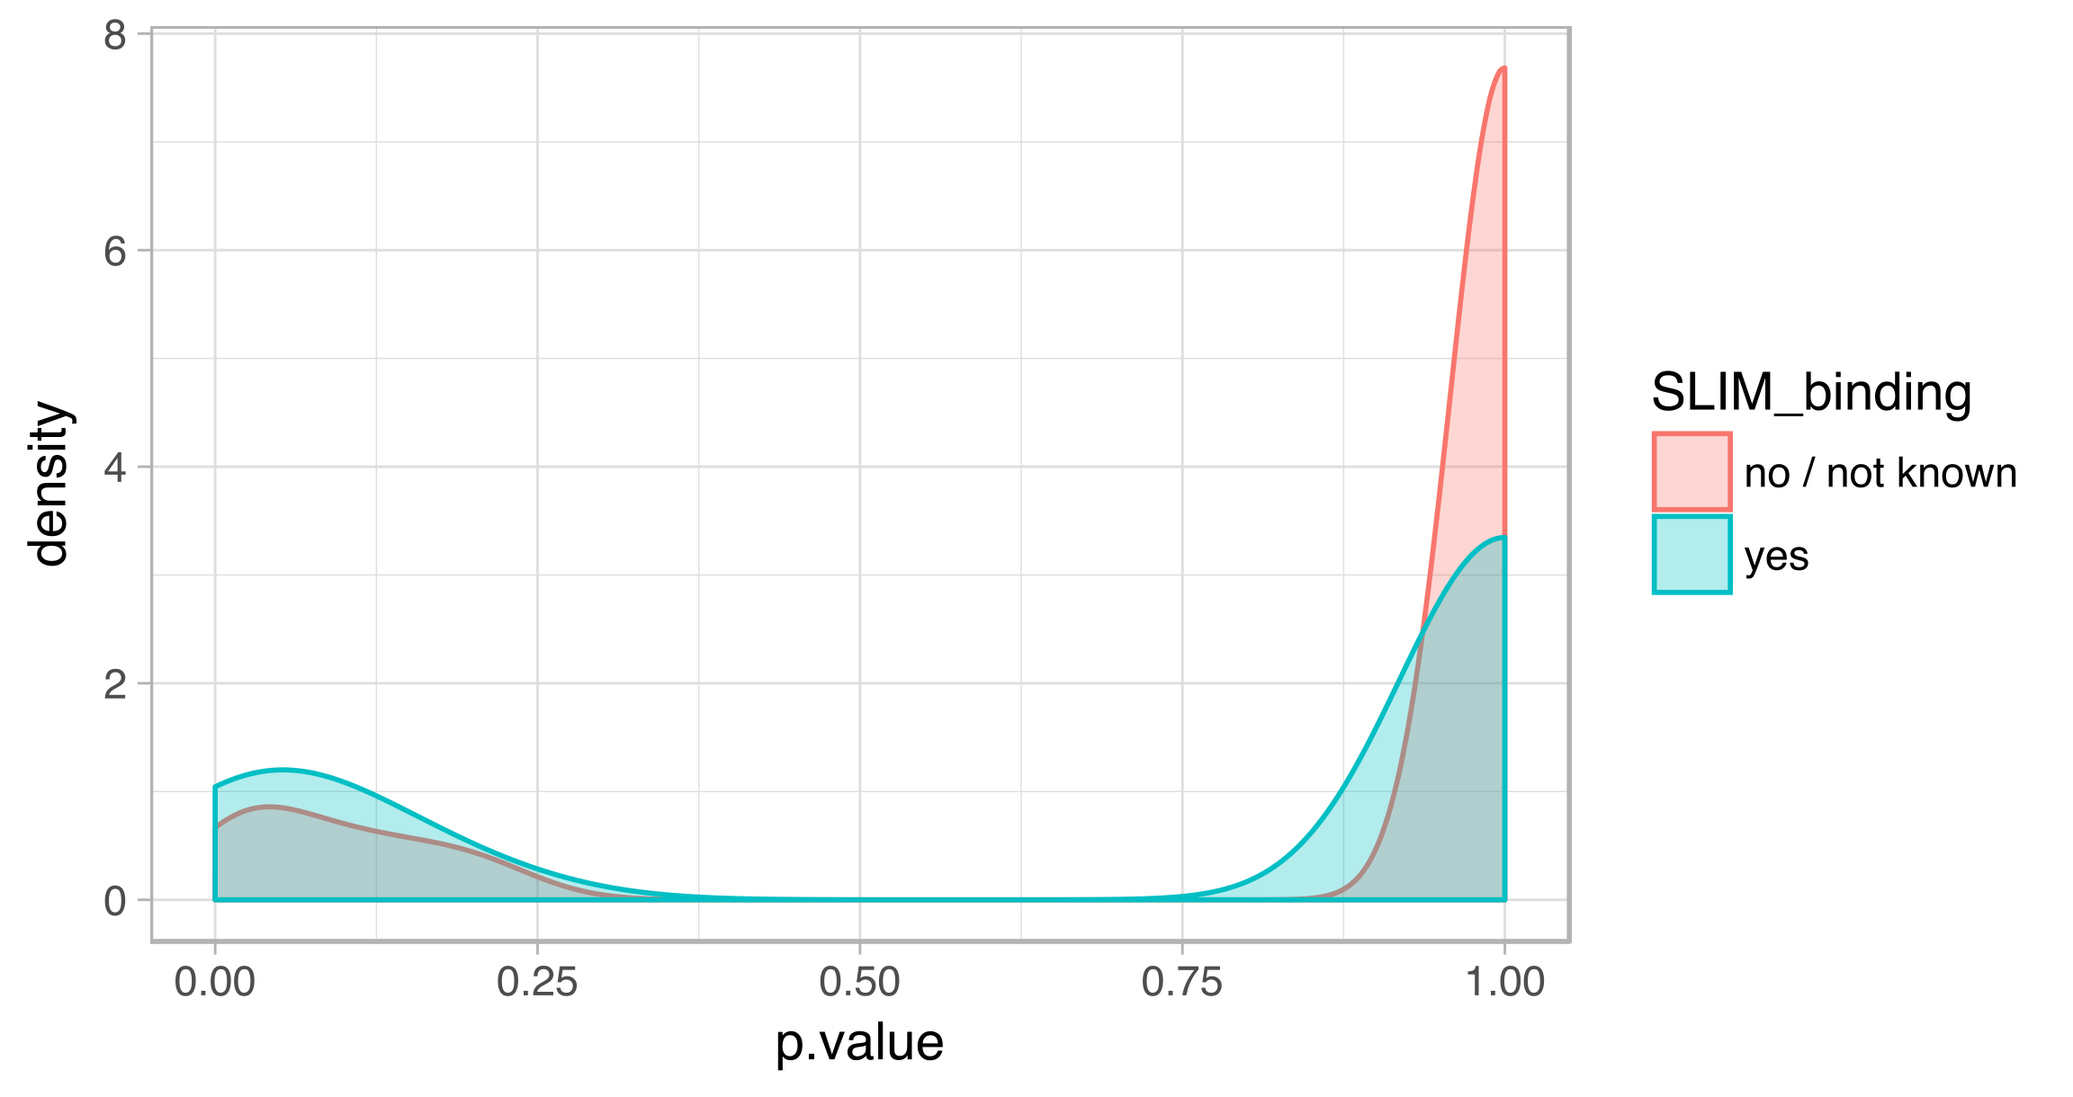

Figure 3.De-novo discovery of Short Linear Motifs

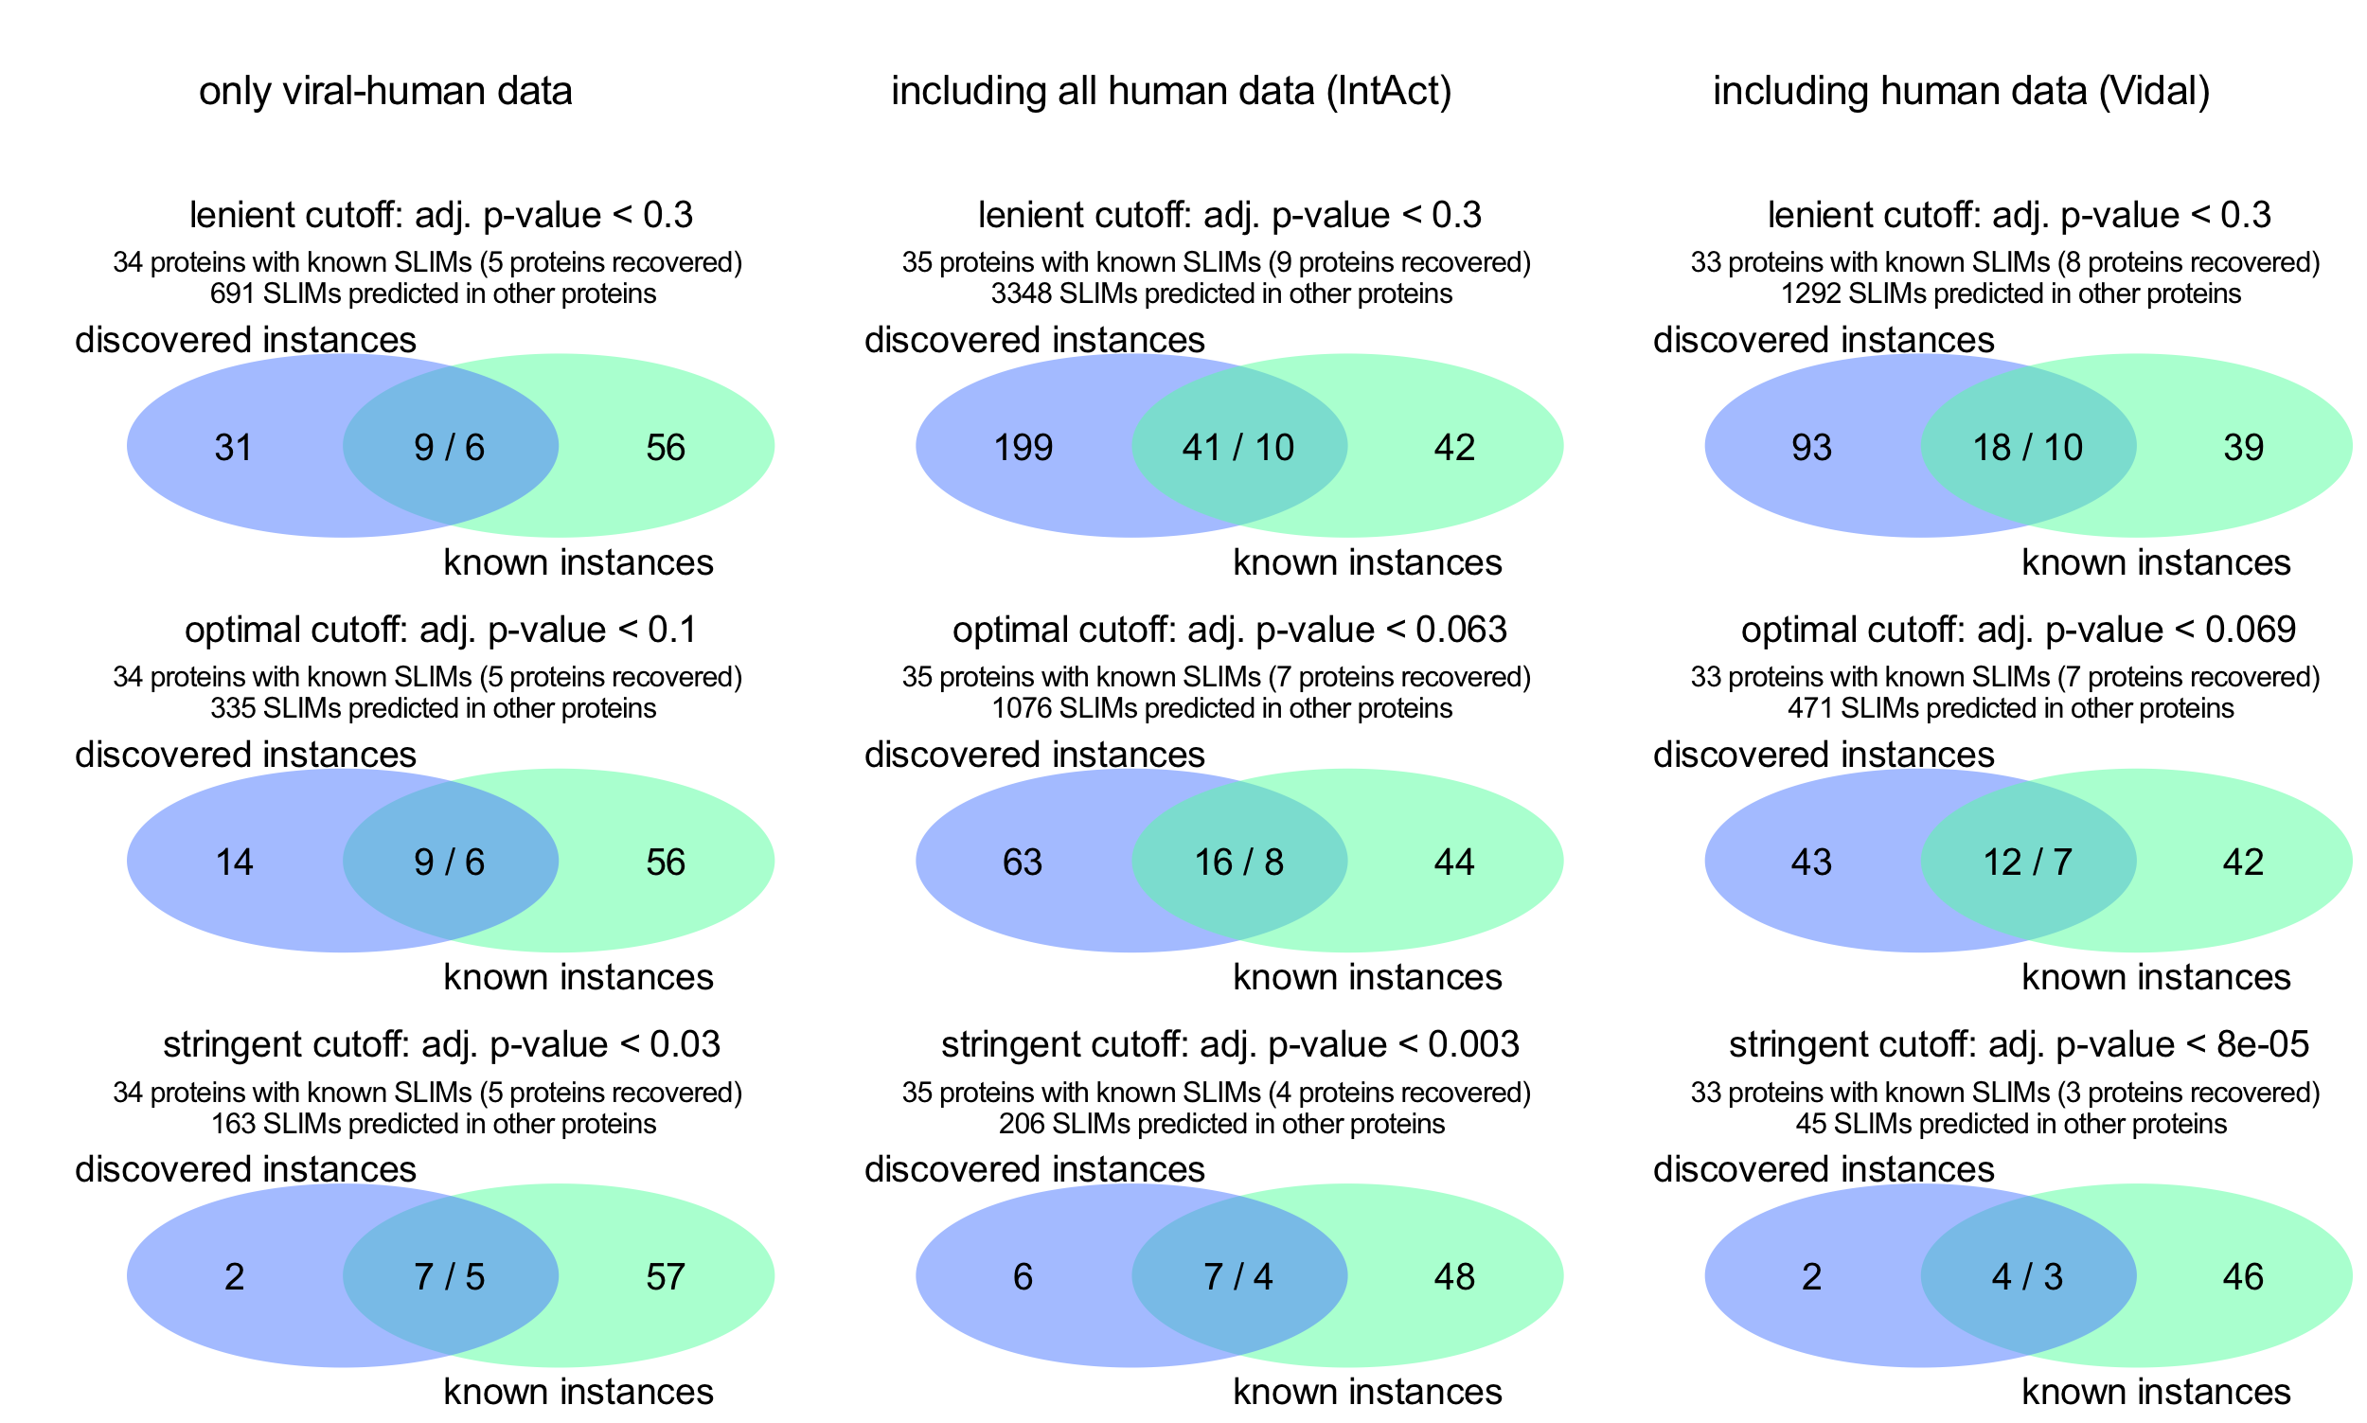

Figure 4.

Filtering by domain improves accuracy of motif prediction

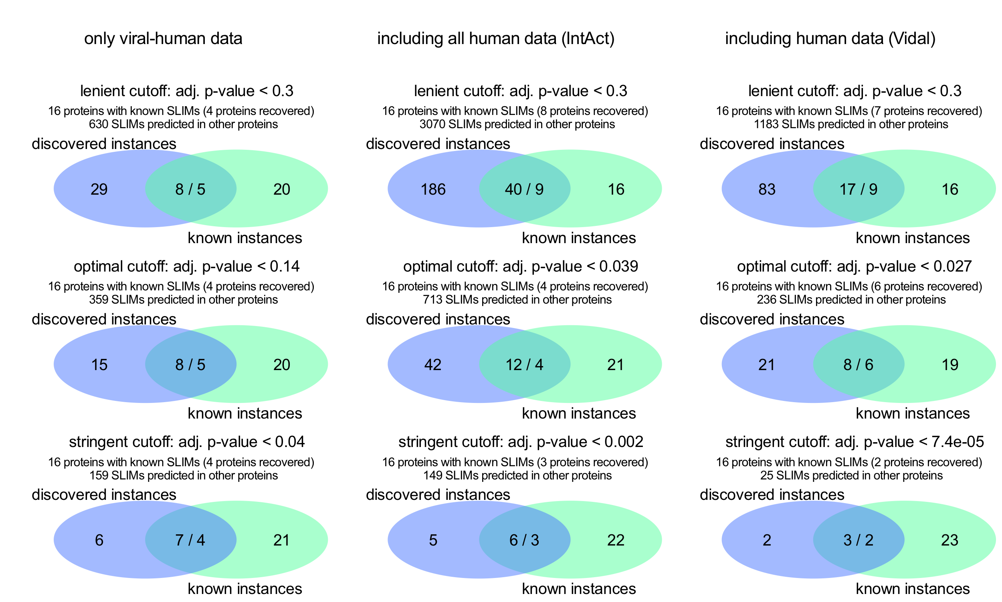

Figure 5.

De-novo discovered motifs are similar to known motifs

To explore which candidate short linear motifs we discovered, we examined which known motifs are similar motifs selected under the stringent threshold. All of these motifs resemble known motif in the ELM database (matching sequence with 0.5 information content). We summarise similarity results further filtered to avoid excessive assignments in Figure 5.

We see a clear cluster of nuclear localisation signal (targeting) motifs that have KR-containing pattern. We also see proline-rich motifs ( P..P.[HKR] and P..P.P.D ) recognised as SH3 domain ligands.

Pattern similarity comparison is very prone to overprediction and at the same time may not capture low information content motifs (very few defined positions). For example, classic C-terminal PDZ domain-binding motif was not recognised.

Whether other pattern similarity matches of candidate motifs are likely to represent the correct motif class requires further investigation. A more robust way of identifying motif classes into match motif pattern similarity and whether these motifs have a correct matching recognition domain.

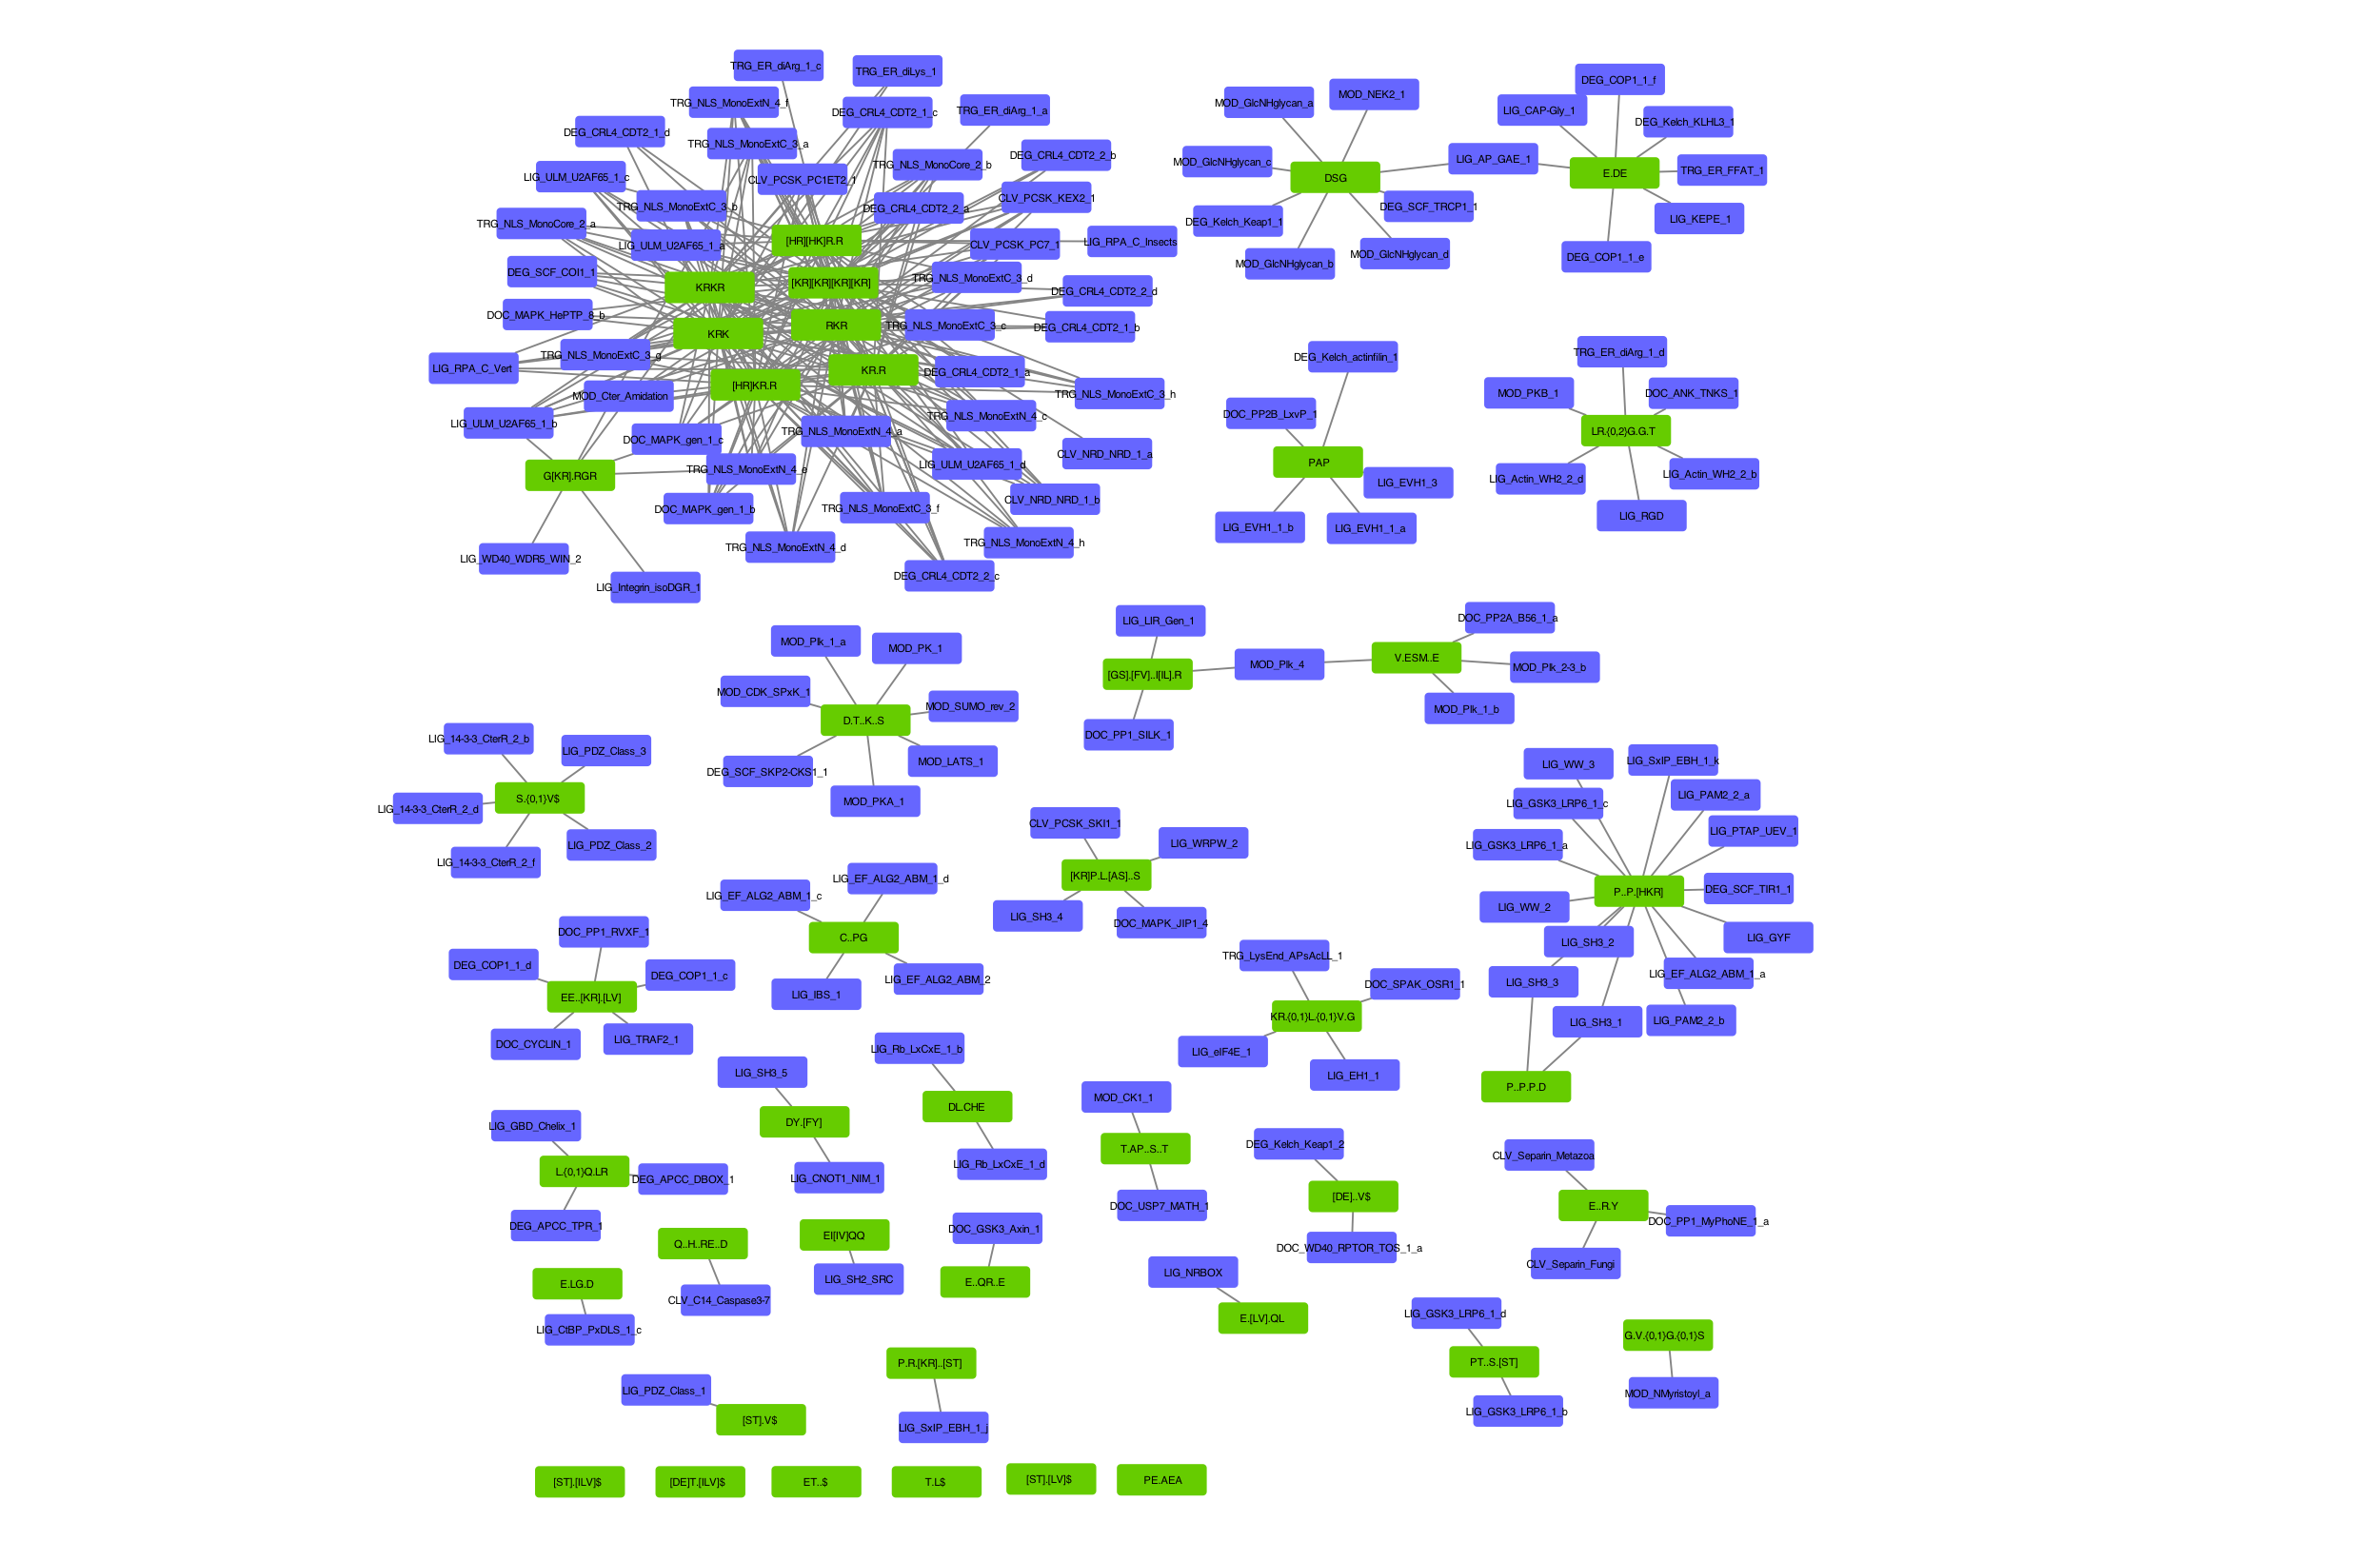

Figure 6. Network of similarity of pattern of discovered short linear motifs to known motifs. Green nodes are discovered motif patterns, blue nodes are known SLIMs in ELM database, edges show the similarity between motifs above 1.162 threshold (Score, Comparimotif3).

Examples of recovered and candidate motifs

Several classes of candidate motifs recovered and predicted alongside and their likely recognition domains

To examine hit produced by a combination of human-viral and full human-human (IntAct) networks I selected candidate motifs under the most stringent threshold (precision > 0.5 or 1 candidate motif per each known motif). This dataset offers more explanatory power because in addition to a motif that has convergently evolved in a viral protein it predicts motifs in the human protein used to bind the same recognition domain (although we have not estimated if these human proteins prefer the same domain - a tip for future work). I manually examined predicted motifs and their most likely recognition domains. These results are summarised Supplementary Table 2.

Encouragingly, the most prevalent group of candidate motifs were not targeting motifs but classic C-terminal ligand-binding motifs ( [ST].[LV]$ ) recognised by a PDZ domain. 26 variants of these motifs ( [ST].[LV]$, [DE]T.[ILV]$, ET..$, [ST].V$, [DE]..V$, T.L$, [ST].[ILV]$ ) were predicted at C-terminus of 16 viral proteins that bind to 7 PDZ-domain-containing human proteins. 2 instances of these motifs were already known and will be discussed in the next section. For all of these instances except (3 in 2 proteins), PDZ-domain was correctly identified as the most likely or one of the most likely domains mediating interaction.

As expected, one of the most prevalent groups of candidate motifs were 14 nuclear localisation signal (targeting, TRG, KR-rich motif) motifs present in 11 viral proteins that bind to 4 human proteins (nuclear import machinery) each containing an Armadillo-like domain - correctly picked up by our domain enrichment procedure. Many of other viral proteins used in our study are localised to the nucleus but were not found to interact with nuclear import machinery suggesting that the motifs observed may be mediating a more stable interaction. An alternative explanation is that viral proteins containing motifs are abundant enough to bind enough copies of nuclear import machinery for these interactions to be detected, a hypothesis supported by the fact that many of these motifs are located in capsid proteins. Domain enrichment also picked up the Armadillo-like domain as the most likely for a couple of motifs that do not resemble nuclear localisation signal ( E..QR..E, D.T..K..S, PT..S.[ST], V.ESM..E ). We found two of these motifs using interactions of human proteins that do not belong to nuclear import machinery (26S proteasome non-ATPase regulatory subunit 1 - E..QR..E motif; E3 ubiquitin-protein ligase HUWE1 - PT..S.[ST] motif). Further investigation of these candidate motifs is required to determine if the Armadillo-like domain of these proteins may be binding non-canonical ligands.

Instances of several other ligand-binding motif classes were predicted: 4 candidate WD40 motifs, 1 SH3 motif, 1 EF-hand motif, 1 PH domain-like. Some of these motifs are further examined in the following sections. Some of these candidate motifs have domains that are not known SLIM-binding domains as tagged as the most likely, including 1 Cyclin-like, 1 Keratin type 2 head, 2 Gro-EL-like and 7 BAG domain binding candidate motifs (refer to Supplementary Table 2). However, both motifs and domain may have been found in error, so further investigation is needed prior to experimental validation.

Successfully recovered 2 known PDZ-domain binding motifs

At a stringent confidence threshold (precision > 0.5) we have recovered 2 known PDZ-domain binding motifs.

Figure 7.

Figure 8.

PDZ-domain binding candidate motifs

Figure 9.

SH3-domain binding candidate motifs

Figure 10.

WD40-domain binding candidate motifs

We predict DSG motif as a candidate WD40 binding motif located in two viral proteins of two viral species: Vpu protein of Human immunodeficiency virus (P05919) and Large T antigen of SV40 virus (P03070). This motif is recognised by two F-box/WD repeat-containing proteins (FBXW11 also known as β-TRCP1 and BTRC also known as β-TRCP2) which both serve as a substrate recognition subunit of SCF (SKP1-CUL1-F-box protein) E3 ubiquitin-protein ligase complex that ubiquitinates and targets proteins for proteasomal degradation [10648623, 10066435]. SCF (FBXW11 or BTRC complex) is a part of signalling pathways including Wnt-beta-catenin and NF-kappaB pathways where it targets either beta-catenin (phosphorylated by GSK3beta) or IkappaB for degradation thus inhibiting (beta-catenin) or activating (NF-kappaB) the transcription factor at the end of the pathway [10321728, 10437795].

Vpu has a known DSG..S motif instance (DSGNES) that allows HIV to hijack SCF ubiquitin ligase to degrade host proteins such as the Antiviral Factor Tetherin/BST-2 and CD4 [PMC2729927, 9660940]. This motif (when phosphorylated at both serines) is normally recognised by FBXW11 and BTRC targeting motif-containing protein for degradation. Apparently, Vpu has found a way to escape self-degradation. This case serves as a validation of our motif discovery procedure: a true motif not represented in ELM database – the data we used to select optimal parameters and the threshold.

Large T antigen (TAg) of the SV40 virus is not known to have a DSG motif. This protein interacts with a tumour suppressor and a DNA damage sensor P53 (this is how P53 was discovered) [PMC353757]. A regulator of P53 a ubiquitin ligase MDM2 contains a known DSG motif and is itself degraded by β-TRCP1/2 discussed earlier [PMC3494375]. TAg of the SV40 virus doesn’t have a DSG..N motif validated (note the substitution of the last serine to asparagine) its homolog TAg protein of JC virus does [PMC3017642]: where both serines are required for phosphorylation.

To get a better idea of the structural aspect of this interaction I have performed docking of three peptides to β-TRCP1/ FBXW11 using pepsite 2 (PDB 1P22, chain A). This analysis indicates that a short DSG motif that we predict may have a binding site in FBXW11, however, not with very high confidence. In addition, DSG motif is predicted to bind F-box rather than WD-40 motif that we predict using domain enrichment procedure. Surprisingly, docking a full sequence of the known motif (DSGNES) of Vpu or TAg of SV40 motif (DSGHET) do not have a high-confidence binding site predicted by Pepsite 2 either.

Both DSG motifs have the very strong support of 24/36 (FBXW11) or 29/56 (BTRC) proteins with motif among non-similar proteins (below BLAST p-value threshold of 10-4) that interact with FBXW11 or BTRC.

Figure 11. Network of DSG motif

The second candidate WD40-binding motif was predicted in Polymerase basic protein 2 (PB2) RNA-polymerase of 2 Influenza A virus strains (B4URF7 protein in strain A/WS/1933 H1N1, C5E527 protein in A/New York/1682/2009 H1N1). We also predict this motif in 4 human proteins that all bind human Elongator complex protein 1 (ELP1). ELP1 is involved in elongation of transcription by RNA polymerase 2 as a part of a complex that plays a role in chromatin remodelling and acetylates H3 histones [22854966]. WD40 prediction as the most likely domain is supported by 9/210 proteins or 5/140 proteins containing that domain (for each viral strain respectively). Given the RNA-polymerase function of PB2, we can hypothesize that it also hijacks host elongation factors via E.V..G.{0,2}N.{0,1}Q motif to facilitate this process.

Figure 12. Network E.V..G.{0,2}N.{0,1}Q motif (WD40 domain, O95163 human protein).

Double-stranded RNA-binding domain and EF hand domain - candidate motifs

We predict LR.{0,2}G.G.T motif that may be recognised by double-stranded RNA-binding domain of Q96SI9 – human spermatid perinuclear protein that recognises viral RNA. We predict this motif in 6 non-structural viral proteins of 4 influenza A strains and 4 human proteins (Figure 12). These viral proteins are involved in blocking the translation of host mRNA [8525619] and also inhibit TRIM25 mediated ubiquitination which is a part of antiviral response [23209422]. We can speculate that this motif mimics RNA that this human domain normally recognises.

Figure 13. Network of LR.{0,2}G.G.T motif (Double-stranded RNA-binding domain, Q96SI9 human protein).

EF-hand domain-binding motif. Cab45 is an EF-hand domain and Ca(2+) binding protein which is necessary for the sorting of secretory proteins at trans-Golgi network. Cab45 oligomers bind secretory and plasma membrane proteins [27138253] and target them to plasma membrane / extracellular space. This protein is not known to interact with viruses besides a recent high-throughput effort to profile interactomes of multiple Influenza A virus strains [28169297]. Cab45 is targeted by 12 distinct viral proteins from 6 viral taxa, although, these interactions were profiled using affinity purification methods that measure both direct and non-direct interactions. A viral protein (PB1, Q5EP37) that targets Cab45 and contains EI[IV]QQ motif is one of the RNA-dependent RNA polymerases of Influenza virus and is an essential component of viral transcription machinery [23600869]. RNA polymerase proteins (including PB1) stays bound to viral RNA and are packaged into viral particles. We can hypothesise that Cab45 serves to facilitate this process. Although feasible, the confidence in this hit decreases because unlike DSG motif described earlier, this candidate EF-hand binding motif was discovered only in 4 out of 33 protein sequences (partners of Cab45) and the domain relevance is supported by only 2 out of 45 PB1-binding proteins (Figure 13). Examining 3 human proteins predicted to have this motif may clarify how likely this motif is to represent a real hit.

Figure 14. Network of EI[IV]QQ motif (EF hand domain, Q9BRK5 human protein).

BAG-domain binding candidate motif

   We found a candidate motif ( L.{0,1}Q.LR ) potentially recognised by BAG domain in seven repeats in the Epstein-Barr nuclear antigen leader protein 5. This motif is found in 13 other proteins that bind to human co-chaperone BAG2 and is also predicted as that mediating interaction with a related protein BAG3 but at a lenient significance level. The Epstein-Barr nuclear antigen leader protein 5 (EBNA5) is one of the first proteins detected during EBV infection and is essential for transforming B-cells by acting as a transcriptional co-activator [29462212, 16177824]. BAG2 and BAG3 are HSP70 and HSC70 co-chaperone proteins and work as nucleotide exchange factor [9873016]. This way EBNA5 may enhance HSP70 and HSC70 chaperone activity or affect cell proliferation or apoptosis via functions of BAG2 or BAG3. Examining 13 other proteins in which this motif was predicted motif will provide more evidence if BAG domain may indeed recognise L.{0,1}Q.LR motif. However, a prediction of viral peptide (LGQLLR) binding on a PDB structure of mouse BAG3 (1uk5) or human BAG1 (3fzf) domain using pepsite 2 [22600738] does not indicate a presence of a strong binding site in this domain (http://pepsite2.russelllab.org/match?molvis=jsmol&pdb=1uk5&chain=A&ligand=LGQLLR).

Future directions

Motif-domain molecular docking

Integrating multiple predictors: domain, motif, molecular docking

Experimental validation

Conclusions

Methods

Protein interaction data

Intact, description of subsets. Randomised network

Keeping isoforms

Degree distribution analysis

Protein sequences and domain prediction

Uniprot REST api.

Interpro.

Removing redundant domains. Combining with viral-human interaction data

Estimating which domains are likely to mediate interaction

Motif Search tools and setup

Benchmarking instances of motif

Dataset

Dataset used for benchmarking was retrieved from ELM database in November 2017. Two files were downloaded using ELM REST API that complement information contained in each one (<http://elm.eu.org/instances.gff?q=all&taxon=irus&instance_logic=>; <http://elm.eu.org/instances.tsv?q=all&taxon=irus&instance_logic=>).

Motif pattern similarity

Data analysis in R

R packages:

* MItools - getting and manipulating PPI data: <https://github.com/vitkl/MItools>
* SLIMFinderR - I plan to move the code for using SLIMFinder in R from MItools to this new package: <https://github.com/vitkl/SLIMFinderR>
* viral_project: all analysis code, some data and most of the results: <https://github.com/vitkl/viral_project>. This is a private repository (until this gets published) so I have created an account for petsalakilab (password whole7cell) and share this project with petsalakilab.

# Supplementary materials

## Supplementary figure 1



## 

## Supplementary figure 2



## Supplementary figure 3



## Supplementary figure 4

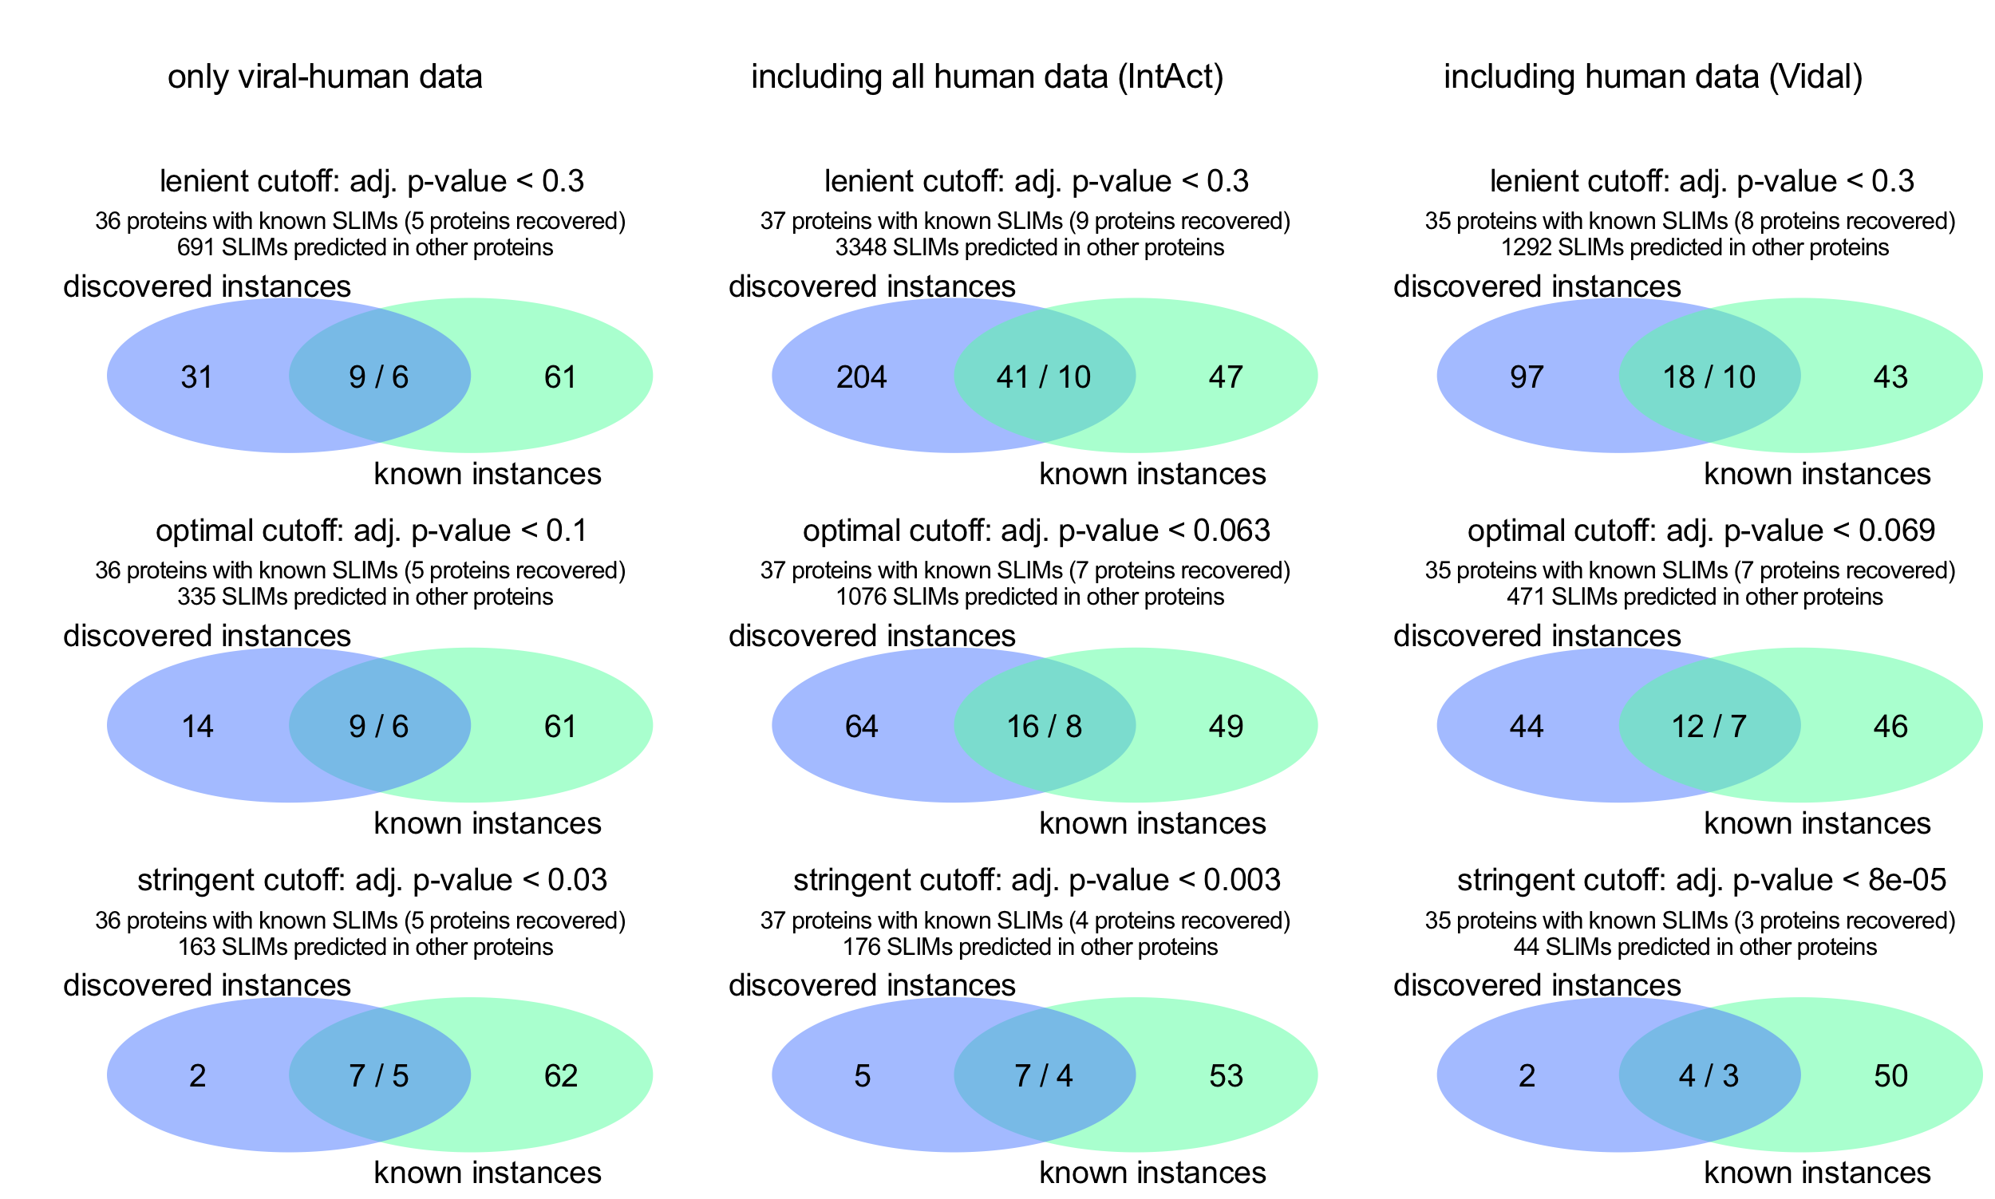

## Supplementary figure 5

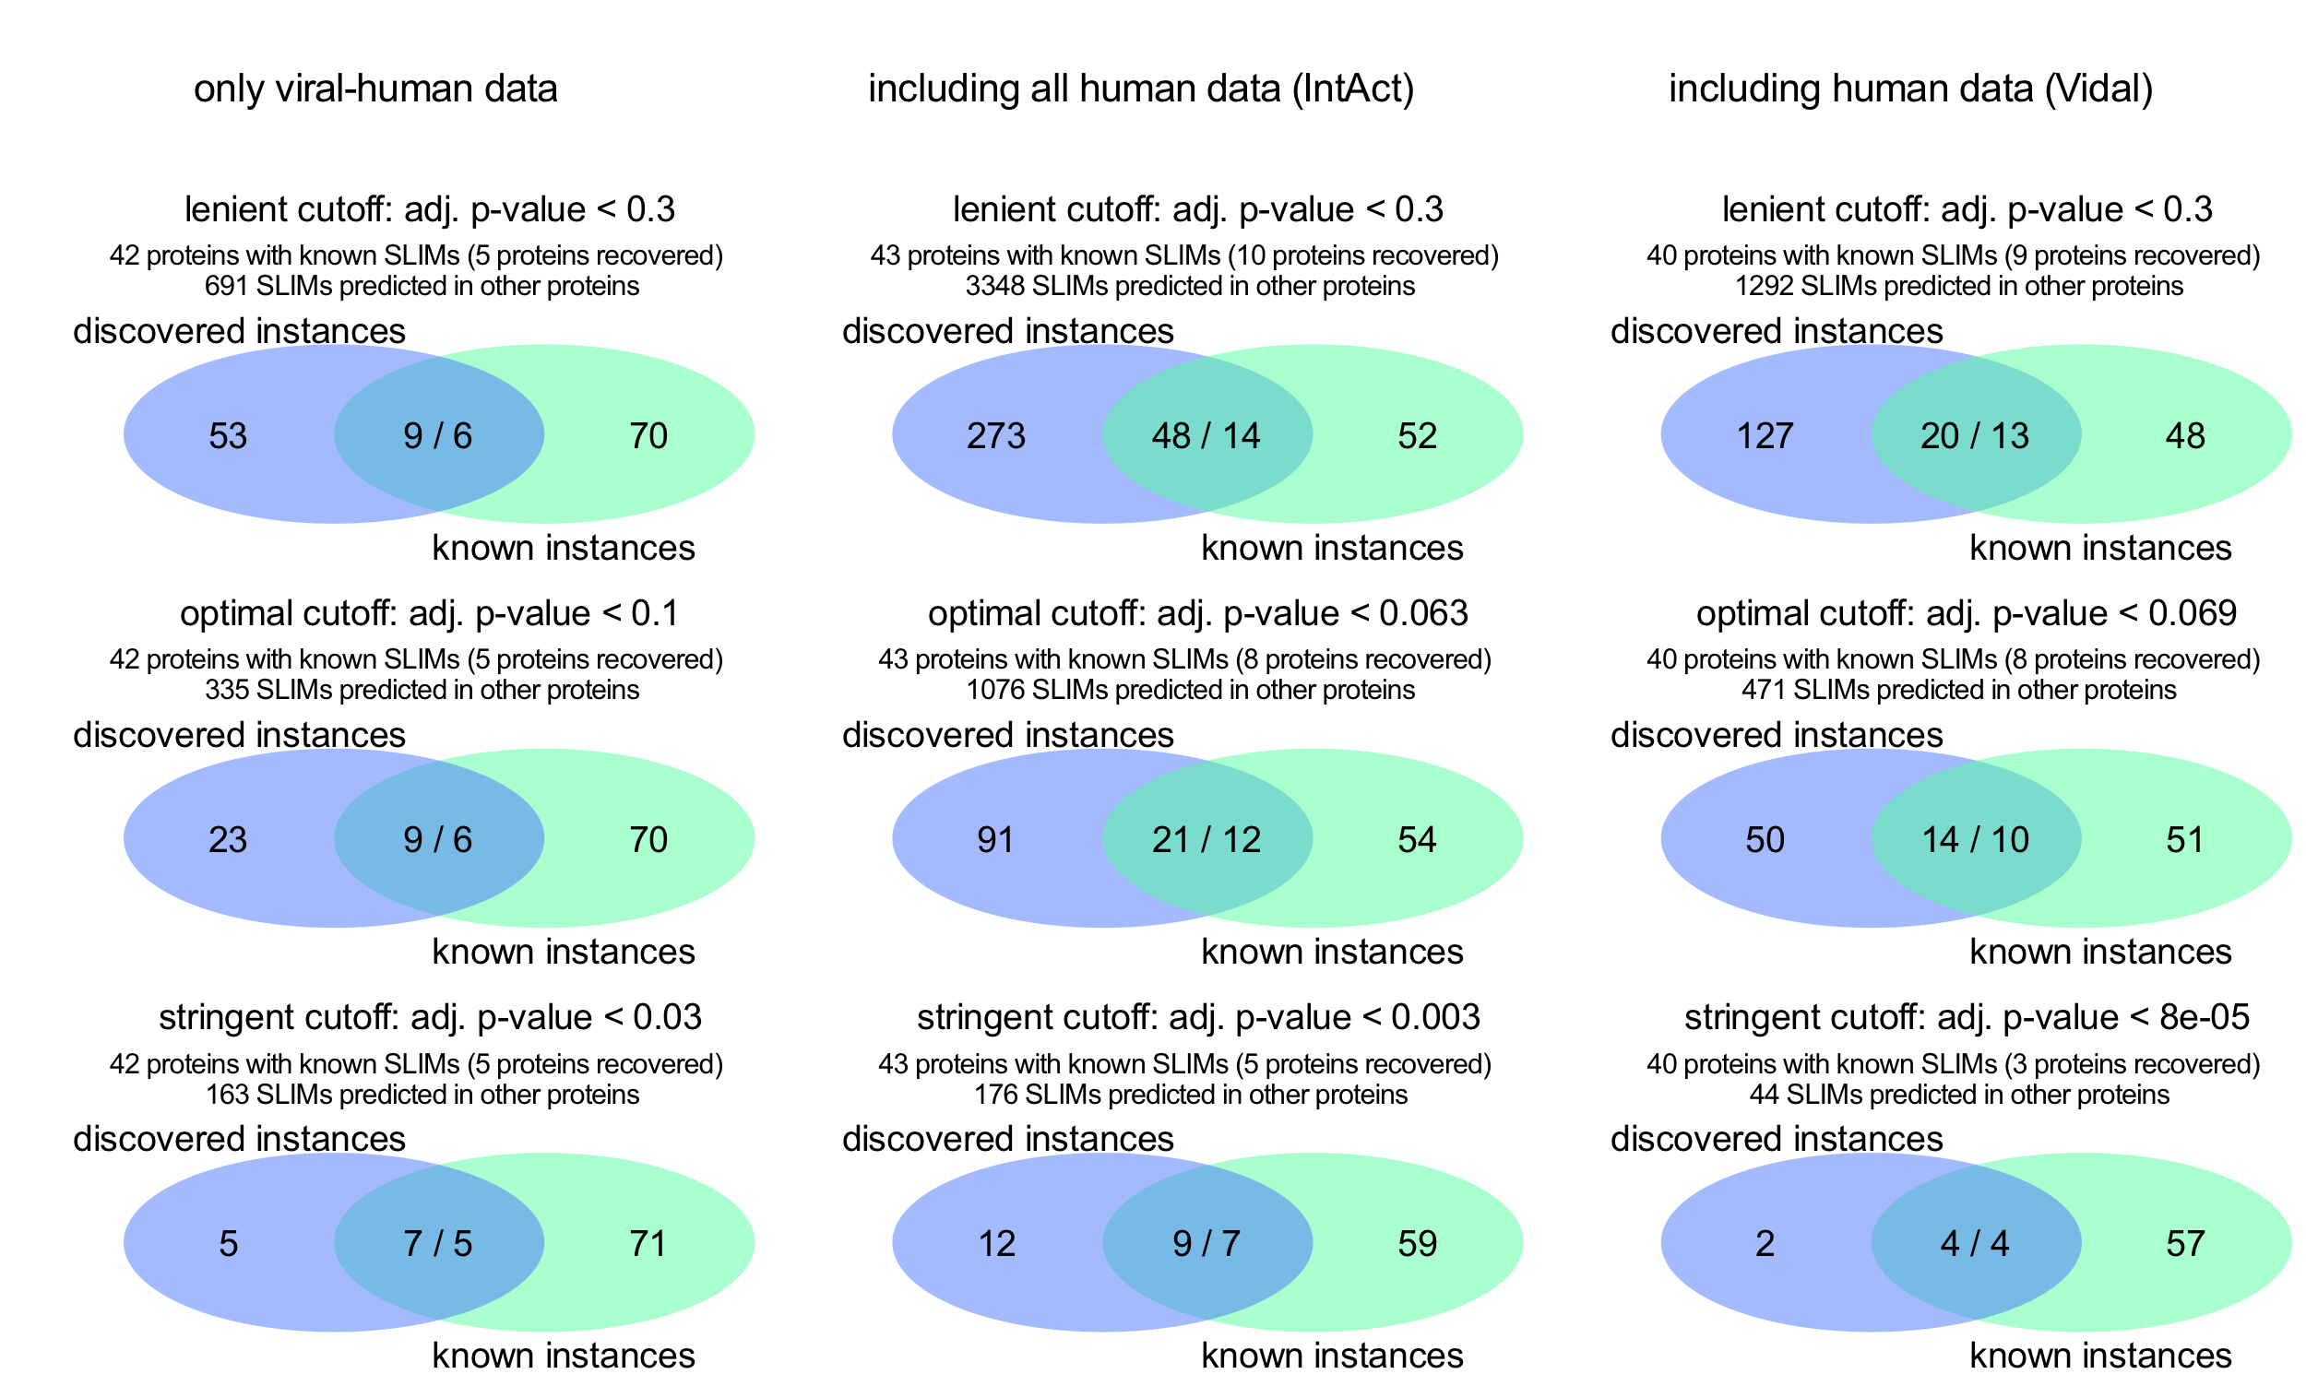**Supplementary figure 6**



## Supplementary figure 7

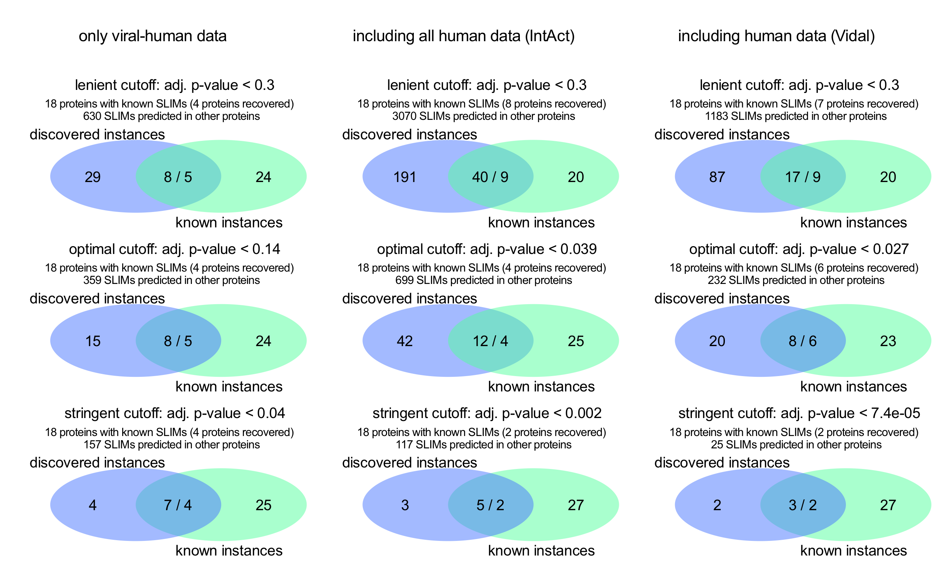

## Supplementary figure 8

